J & K POLICE PUBLIC SCHOOL, MIRAN SAHIB, JAMMU
HOLIDAYS HOMEWORK, FOR WINTER VACATION ,(2018-19)
SUBJECT- ENGLISH CLASS- V
- Read newspaper daily and write 5 difficult words and write their meanings.
- Write five pages of cursive writing on your notebook.
- Visit places of your interest with your family and write few lines in your own words sharing your experiences.
- Learn all the syllabus of final term that has been done so far in the class.
Note:- Do this home work in a separate Rs. 10 notebook.
SUBJECT- EVS
- Draw the life cycle of a mosquito on A4 size sheet.
- Prepare a model of an aquarium.
- Paste the pictures of Indian astronauts on A4 size sheet.
- Learn Chapters from 15- 17.
SUB-MATHS
Q1. Revise all the syllabus done in the class.
Q2. Measure the height and weight of your family members and make a proper chart of it.
Q3. Measuring your house.
- What is the width of your house?
- What is the length of your house?
- What is the height of your house?(not including the roof section)
- What is the perimeter of the base of your house?
- What is the area of the base of your house?
Q4. Prepare a model of
- 12 hour clock (Roll no. 1 to 18)
- 24 hour clock (Roll no. 19 to 37) 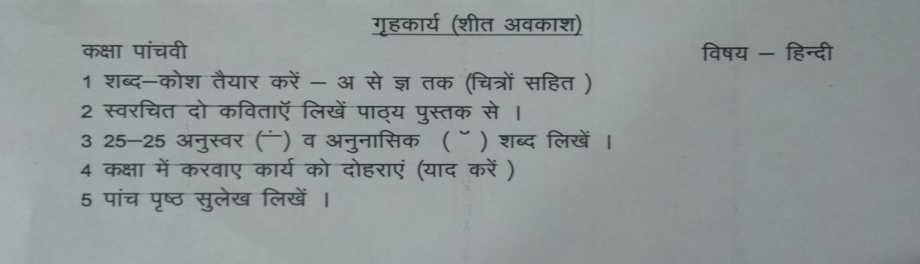
SUBJECT-COMPUTERS
Q1. What is a Computer?
Q2. What is a CPU? Draw with diagram.
Q3. Write 5 INPUT and 5 OUTPUT device name.
Q4. Write full form of given words.
1. Ram 2. Rom
3. CD 4. DVD
5. PC 6. OS
Q5. Draw the diagram of Computer Component device.
- Note:- Learn & revise all the syllabus that you have done in the class.

