J&K POLICE PUBLIC SCHOOL,MIRAN SAHIB,JAMMU
HOME-WORK FOR WINTER VACATIONS,SESSION (2018-19)
(CLASS-2ND)
SUB-ENGLISH
1. Do page writing in cursive. (5 pages)
2. Paste the pictures of any two indoor and two out door games. Write the number of players who take part in each game.
3. Make a beautiful NEW YEAR GREETING CARD and write a message to your grand-parents or parents wishing them a Happy New Year(2019) 4.Revise the syllabus of Cycle Test. ____________________________________________________________________
SUB-EVS
1..Write the names of any five different plants or trees you find in your surroundings.
2.Plant a sapling in a small pot. Water it everyday and bring it to the class after the vacations.
3.Draw pictures of any 4 insects with your thumb impressions using water colours.
4.Revise the syllabus of Cycle Test.
------------------------------------------------------------------------------------------------------------------------------
SUB-MATHS
1.Measure and write down the length of your dining table, your maths book and your pencil using your scale.
2.Count and write how many cups of water your water bottle and two different vessels of your kitchen can hold using the same cup. Note down which vessel holds more and less water.
3.Draw different flat shapes and show the fractions one-half, one-third and one-fourth of the whole by colouring them.(any six)
4.Revise the syllabus of Cycle Test. NOTE: Do all the work on a separate 3-in -1 notebook.
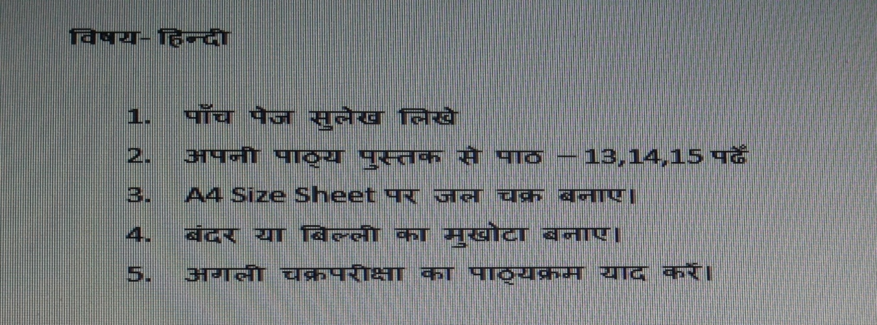

Subject : Computer
Q1. Guess my name!
- I am a place where computer is used to take medical tests.
2. I am a place where computer is used to prepare bills.
3. I am a place where computer is used to deposit money.
4. I am a place where computer is used to launch a rocket.
5. I am a place where computer is used to make films.
Q2. Collect two pictures of “Places where computers are used” paste them on the scrap book
Q3. We all have extra CD’s at home which we are not using, so let us become some creative by making Diya stand by using your old CDs
- Note:- Learn & revise all the syllabus that you have done in the class.

