J & K POLICE PUBLIC SCHOOL, MIRAN SAHIB, JAMMU
HOLIDAYS HOMEWORK, FOR WINTER VACATION ,(2018-19)
SUBJECT-ENGLISH CLASS-IV
- Read L-11 and write how many characters are there in the lesson and name them and write a at least five lines on any one the character of the same lesson.
- Write five pages of cursive writing on your notebook.
- Visit places of your interest with your family and write few lines in your own words sharing your experiences.
- Learn all the syllabus of final term that has been done so far in the class.
Note:- Do this home work in a separate Rs. 10 notebook.
SUBJECT –EVS
- Prepare a model on water cycle.
- On A4 size sheet make a poster on save and conserve water.
- Write a story of a train journey using these terms-Online booking, reservations, ticket collector, railway station, coolie, guard, pantry etc.(on A4 size sheet.)
- Learn Chapters from - 14 to 16.
SUB-MATHS
Q1. Revise all the syllabus done in the class.
Q2. Make a list of four things that weigh less than 1 kg
Q3. Collect the information regarding the area of your state.
Q4. Measure the height and weight of your family member and make a proper chart of it.
Q5. Project work
a. Paste the dummy currencies of your neighbouring countries on A4 size sheet.
b. prepare a model of 12 hour clock on a thermocol sheet.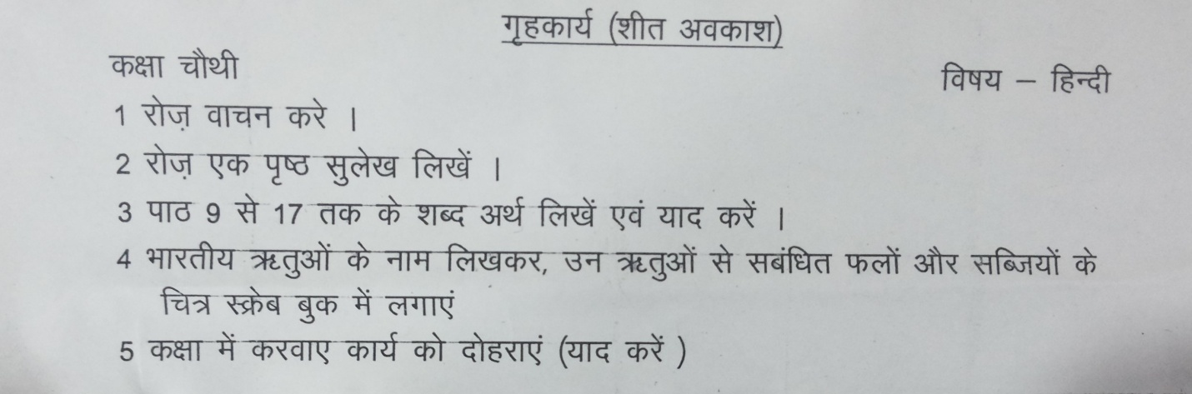
SUBJECT- COMPUTERS
Q1. Write full form of given words.
1. Ram 2. Rom
3. CD 4. DVD
5. OS 6. SW
Q2. Who is the father of modern Computer?
Q3. Write full form of COMPUTER.
Q4. Write two Search engine name.
- Note:- Learn & revise all the syllabus that you have done in the class.

