J & K POLICE PUBLIC SCHOOL, MIRAN SAHIB, JAMMU
HOLIDAYS HOMEWORK, FOR WINTER VACATION ,(2018-19)
SUBJECT-ENGLISH CLASS-III
1. Find out the rhyming words from the poem “ Evening”.
2 .Go through the newspapers and take a few pictures related to a cricket match that was played recently. Paste them in your notebook . Underline the names of cricketers mentioned in it and copy the names in your notebooks.
3. Read the chapter --- n Exciting cricket Match and find out difficult words and learn and write it.
4. Write down the question – answers and exercise of poem – Evening.
SUBJECT-MATHS
Q1 Draw the clocks to show the given timings:-
- Half past 5 (ii) Quarter to 7 (iii) 20 minutes to 8
Q2 Calculate the following
- The minutes in 3 hours (ii) The hours in 6 days
- The minutes in 7 hours (iv) The hours in 3 days
Q3Fill in the blanks:-
- There are ______________ months of the year.
- ______________________is the last month of the year.
- There are ________________days in the month of May.
- If today is Tuesday, then tomorrow will be ______________, and yesterday was________.
- If today is December 31, then tomorrow will be_______________.
Q4 Make a calendar showing dates, days and months (2019). Use red pen to mark Sundays and holidays.
SUBJECT-EVS

- Make a chart on “WATER CYCLE”. ( Roll No. 1to 13)
- Make a model of any means of transport using waste material. ( Roll No.- 14 to 26)
- Find out why vehicles have number plates .
- Revise all the syllabus of final term that has been done so far in the class.
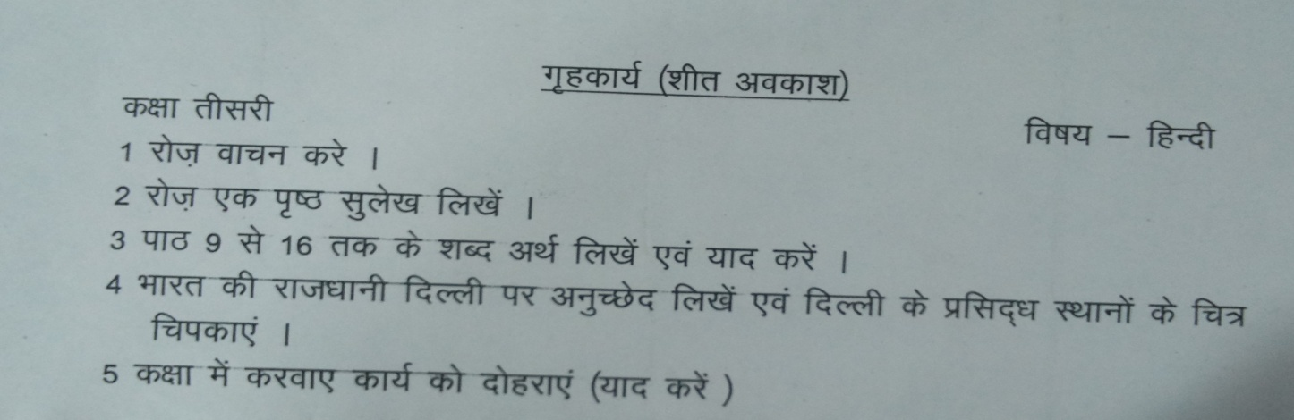

Note: (i) Revise all the syllabus of final term that has been done so far in the class.
- Do this home work in a separate Rs. 10 notebook.

